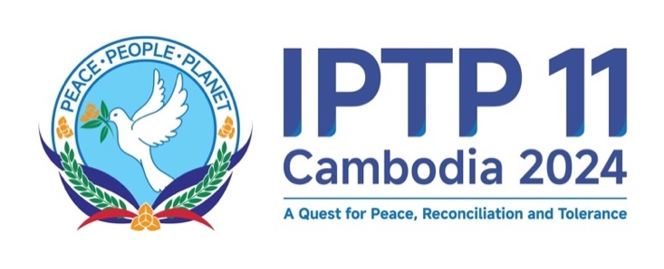

**11th Plenary Session of the International Parliament for Tolerance and Peace (IPTP)**

24 November 2024, Phnom Penh, Kingdom of Cambodia

**\*\*\*\*\*\*\*\*\***

**Report on the Outcomes of the IPTP Committee Meetings**

On 24th November 2024, the 11th Plenary Session of the International Parliament for Tolerance and Peace (IPTP) convened its Committee Meetings in Phnom Penh, Kingdom of Cambodia, under the theme of **“A Quest for Peace, Reconciliation, and Tolerance**”. The session consisted of five core committee meetings: 1) Peace and Reconciliation Committee; 2) International Cooperation Committee; 3) Food-Energy-Water (FEW) and Environmental Security Committee; 4) Science, Technology and Innovation Committee; and 5) Legal and Justice Committee. Overall, the five Committee Meetings covered conflict prevention and peacebuilding, peaceful settlement, post-conflict reconstruction, transitional justice, multilateral cooperation, and food security and sustainable development in response to climate change. In general, the Committees have discussed all core elements prescribed in the Universal Peace Charter which was signed on the same day. In line with this, each committee yielded the following outcomes:

1. **The Peace and Reconciliation Committee** reaffirmed its unwavering commitment to advancing preventive diplomacy, trust-building, and implementing confidence-building measures as vital strategies to mitigate conflicts and de-escalate tensions. The Committee underscored Cambodia’s model of peace and reconciliation, pioneered and implemented by Samdech Techo Hun Sen in the 1990s, as inspiration and lessons the necessity of proactive engagement in facilitating peace negotiations and consultations, ensuring equitable and sustainable outcomes for all stakeholders. Recognising the critical importance of post-conflict rehabilitation and reconstruction, the Committee identified education as a fundamental pillar for promoting sustainable recovery and fostering national healing. Furthermore, it emphasised the imperative of inclusive peace leadership, highlighting the indispensable roles of women and youth in cultivating resilient, harmonious, and cooperative societies.
2. **The International Cooperation Committee** noted the importance of promoting economic and social advancement based on mutual interest, cooperation, equality, dignity, and respect for national sovereignty, particularly by embracing free trade and fair-trade practices with full respect to the international trading systems, to achieve shared prosperity and well-being for all. The Committee also acknowledged the international cooperation that has addressed global challenges, including the COVID-19 pandemic, Climate Change, and the collective efforts toward the 2030 United Nations Sustainable Development Goals (UN SDGs). These efforts highlight the numerous opportunities that multilateralism can offer, such as conflict resolution, technological advancements, and economic cooperation, which can contribute to peace and prosperity for all. The Committee reaffirmed the significance of multilateralism in developing long-term solutions, complementing universally accepted international law and norms, and the Charter of the United Nations to foster global peace. Additionally, the Committee stressed the vital role of strengthening interfaith dialogue and intercultural harmony to build bridges of mutual respect and cooperation.
3. **The Food-Energy-Water (FEW) and Environmental Security Committee** underscored the critical interdependence food, energy, and water, in sustaining peace and security. The Committee advocated for green investment, technological innovation, and resilient agricultural practices to address food security and ensure sustainable food production systems while also maintain natural ecosystems and mitigating the effects of natural disaster, such as extreme weather, drought, flooding, and climate change. The necessity of adopting sustainable development strategies aligned with the United Nations 2030 Agenda for Sustainable Development (UNSDGs) was highlighted, along with measures to preserve natural ecosystems and enhance adaptive capacity in the face of environmental challenges. In this connection, the Committee emphasised the significance of global cooperation to addressing shared issues in achieving food-energy-water and environmental security which are the foundation elements to achieve global peace, security, development, and stability.
4. **The Science, Technology, and Innovation Committee** emphasised the transformative role of digital technologies and scientific innovation in fostering peace and connectivity across various racial, ethnic, and religious communities. The Committee sought to leverage the advancements in information and communication technology (ICT) to combat misinformation, strengthen public transparency and accountability, and close the digital divide. The Committee also highlighted the importance of equitable access to advanced technologies and the ethical use of artificial intelligence to benefit humanity and support inclusive development. Moreover, the Committee also acknowledged the importance of legislative enhancements and international frameworks to support the integration of technology into future innovations that improve and accelerate human progress and humanity values. The Committee emphasised the significant integration of technology into national and global climate strategy, ensuring that technological innovation contribute to mitigating environmental impacts, accelerating the transition to sustainable practices and addressing climate challenges in an inclusive and equitable manner. The Committee therefore expressed a commitment to translating these agendas into actionable steps, aiming to enhance the education, communication, and technology sectors for a more inclusive and interconnected world.
5. **The Legal and Justice Committee** reaffirmed the essential need to deliver justice during peace times and in the post-conflict era to provide peace to the living and justice to the dead, therefore, to prevent further confrontation of conflict, and offer national healing that will build a foundation for enduring peace and reconciliation. The Committee also stressed the importance of truth-seeking processes, restoration of civic trust, and social solidarity to establish durable pathways to peace. In addition, the Committee recognised the interconnectedness of peace and justice, with calls for comprehensive peacebuilding efforts that integrate economic, security, and governance measures. Furthermore, it urged to identify and address existing social, economic, and political injustices through people-centred reforms and peaceful mediation efforts among all parties involved to ensure a Win-Win peace. And more importantly the committee recognised the new model of transitional justice and unique legacy of the Extraordinary Chambers in the Courts of Cambodia (ECCC)in providing justice for the Cambodian people, and a stable and legitimate judiciary in Cambodia; and in helping shape the design of the future tribunal that deal with core crime of international concerns as well as helping develop the future comprehensive development of criminal laws.

The summary report of the IPTP Committee Meetings will be incorporated into the outcome documents of the 11th Plenary Session of the IPTP and will be put forward for the deliberations of an action plan and roadmap for the implementation of the **Universal Peace Charter**. *[End]*