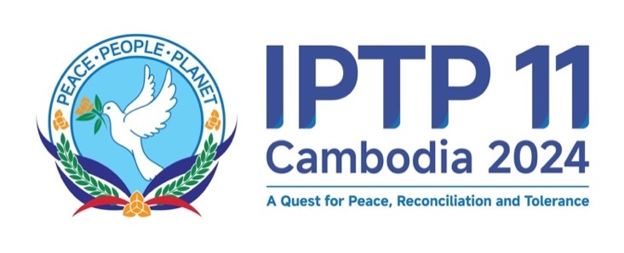

11th Plenary Session of the International Parliament for Tolerance and Peace (IPTP)
24 November 2024, Phnom Penh, Kingdom of Cambodia
*********
Phnom Penh Declaration on
The Endoresement of the “Universal Peace Charter: For People and the Planet”
In A Quest For Peace, Tolerance and Reconciliation”
At the 11th Plenary Session of the International Parliament For Tolerance and Peace (IPTP)
23-26 November 2024, Phnom Penh, Cambodia
***********
We, the Parliamentarians representing the Parliaments or National Assemblies from Asia and the Pacific, Africa, Europe, Latin America, and beyond and the peoples of peace-loving nations and entities from across the globe, are united by a common desire and collective will to live in peace, harmony, dignity and prosperity;
Adhering to the purposes and principles of the Charter of the United Nations, the Bandung Declaration, the Treaty of Amity and Cooperation in Southeast Asia (TAC), and other universally recognised international treaties and conventions on peace with respect to the prevailing international law that serves the common interests of nations and entities in a fair and just manner;
Referring to the Global Council for Tolerance and Peace (GCTP) and International Parliament for Tolerance and Peace (IPTP) 9 Plenary Session in the United Arab Emirates on 27 March 2022, Statement of the Bureau of the IPTP in the UAE on 12 April 2022, GCTP and IPTP 10th Plenary Session in Morocco on 14-15 July 2022, the Siem Reap Declaration “Galvanizing Political Synergy in Peacebuilding under The Universal Peace Charter: For People and the Planet” adopted at the Executive Committee Meeting of Centrist Democrat International (IDC-CDI) on 18 November 2024 and the Phnom Penh Declaration on Peace and Reconciliation adopted at the 12th General Assembly of the International Conference of Asian Political Parties (ICAPP) on 23 November 2024;
Expressing our desire to occupy an honoured place in international society, striving for the preservation of peace and humanity, and ensuring that all people of the world have the right to live in peace and freedom from fear and freedom from want;
Committed to promoting peace, tolerance and sustainable development through enhanced multi-stakeholder dialogues, consultations, collaborations and partnerships;
Underscoring an urgent need for a peaceful diplomatic solution, with full respect of the principles of international law, to the ongoing conflicts in different parts of the world;
Recognising the need to embrace active and proactive peacebuilding approach by developing and sustaining a healthy ecosystem of peacebuilders and inclusive multilateralism centred on a strong synergy of governments, parliaments and civil society organisations in performing their international responsibilities, or voluntary services, and high moral and ethical standards; and
Pledging to build a peaceful and prosperous global community that encompasses the original ideal of creation and bolsters the world of freedom, peace, unity and happiness centring on true love, compassion and kindness.
Hereby declare as follows:
- Endorse the adoption of the Universal Peace Charter: For People and the Planet which articulates a universal peace architecture as an international cooperation framework to promote peace, security, stability and development among nations and communities on the fundamental principles of (i) unity in diversity, sovereignty, territorial integrity, good-neighborliness, friendship, non-aggression, non-interference, prosperity and development, (ii) mutual respect, mutual understanding, mutual trust and mutual interest for peace and prosperity (M4P2), (iii) tolerance, love, equality, fairness and justice, (iv) peaceful co-existence and peaceful settlement of disputes and differences, and (v) culture of peace and dialogue;
- Move forward with the cooperation in the five core pillars espoused in the Universal Peace Charter: For People and the Planet, namely: (i) conflict prevention, (ii) peacebuilding process and Good Offices, (iii) post-conflict reconstruction and response to humanitarian emergencies and disasters, (iv) transitional justice, and (v) food security in response to climate change;
- Accelerate economic growth and social advancement to all nations by embracing free and fair trade with full respect to inclusive, effective and sustainable multilateralism at its core and on the basis of win-win cooperation and respect for national sovereignty to help bring about the common prosperity and well-being of all;
- Commit to addressing global climate challenges and crises by adopting appropriate national, regional and international climate mitigation and adaptation measures to enhance resilience to disasters and to achieve the 2030 Agenda of the United Nations for Sustainable Development and to advance, among others, the Pact for the Future of the Summit of the Future 2024;
- Endeavour to work collectively to raise the awareness and enhance the role of women and youth in building peace and security and in enhancing inclusive, resilient and sustainable development in their respective societies;
- Work collaboratively to harness the full potential of Information and Communication Technology (ICT) and digital technologies to enhance peace and seamless harmonisation of science, technology and innovation with human civilisations;
- Foster harmony among religious and belief systems, cultures and civilisations through dialogue, mutual respect and cooperation in upholding the spirit of promoting people-to-people connectivity, cultural understandings and religious tolerance;
- Explore the possibility of establishing the Universal Parliamentary Assembly as a subsidiary platform of the UN General Assembly to collaborate with other regional and international parliamentary networks or associations to advance parliamentary cooperation and diplomacy in peacebuilding and designated areas of cooperation under the Universal Peace Charter: For People and the Planet;
- Promote the Universal Peace Charter: For People and the Planet by adhering to the principles and purposes of the Charter through collaboration with the United Nations Peacebuilding Commission to galvanise solidarity among parliamentary networks to initiate peace programs including the formation of Peacebuilding Foundation to mobilise and allocate adequate and sustained financing and supporting mechanisms.

Adopted in Phnom Penh, Kingdom of Cambodia, on the 25th of November 2024.

